5 nodes

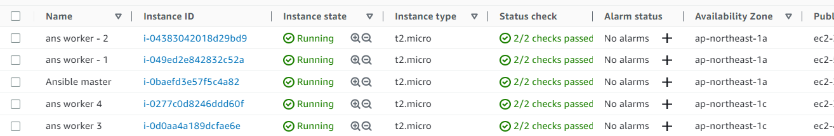

Host file in master :

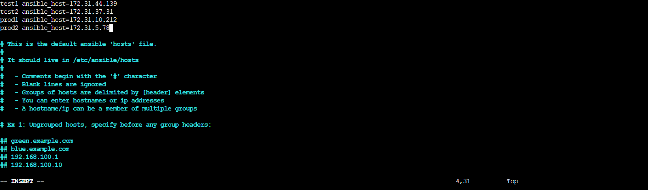

YML file

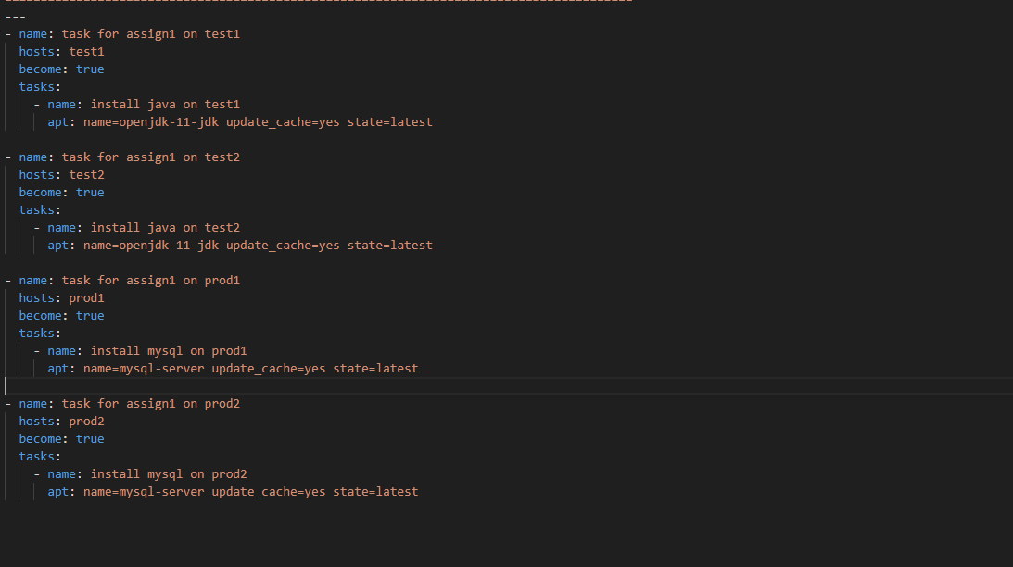

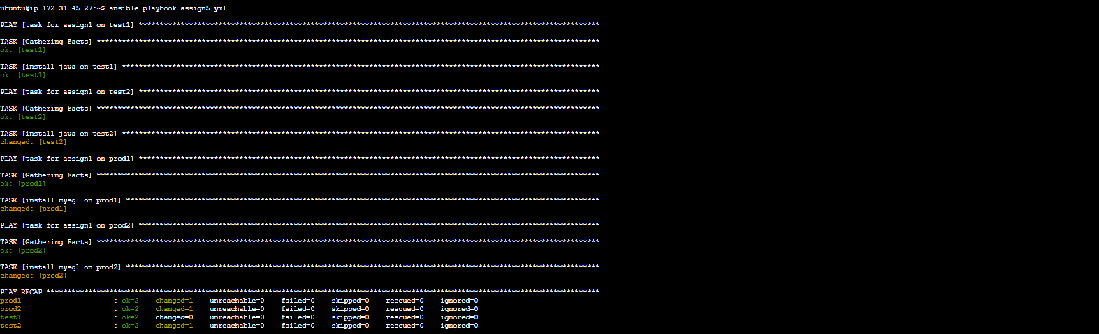

Test 1:

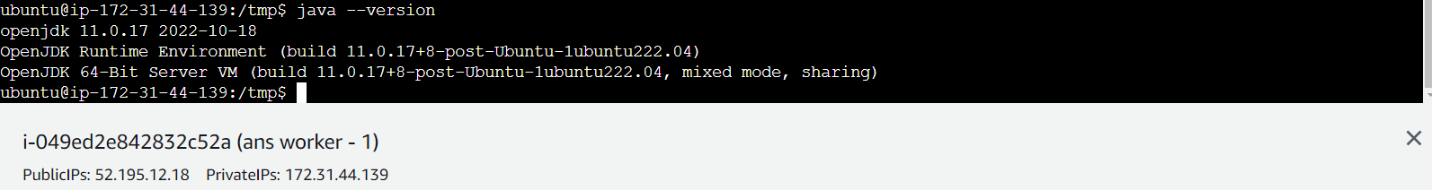

Test2:

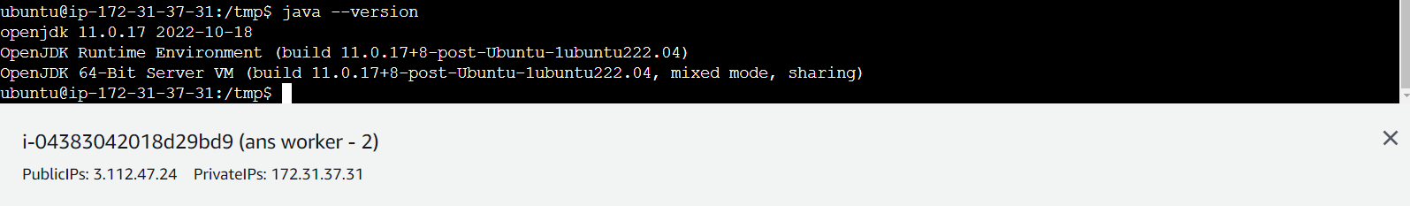

Prod1:

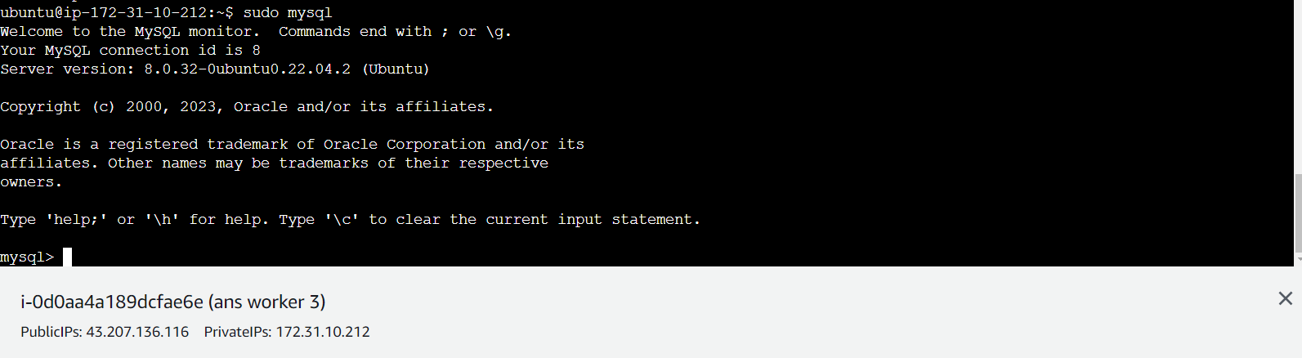

Prod 2:

